2018 OHIO ATHLETIC CONFERENCE
MEN’S & WOMEN’S
OUTDOOR TRACK & FIELD
CHAMPIONSHIPS



Participant Manual
Hosted By:
Ohio Northern University

Kerscher Stadium
Ada, Ohio

Welcome to the OAC Outdoor Track & Field Championships

On behalf of President Dan A. DiBiasio, OAC Commissioner Tim Gleason and the student- athletes, faculty and staff at Ohio Northern University, we welcome you to the 2018 OAC Outdoor Championships. It is a great privilege to host the 2018 OAC Outdoor Track & Field Championships and we hope you enjoy the event here on our campus.

Congratulations to each participant, coach and institution on a great season and getting to the 2018 OAC Outdoor Track & Field Championships.

Tom Simmons
Ohio Northern University Director of Athletics

CHAMPIONSHIP PERSONNEL
OAC Commissioner Tim Gleason
(330) 259-9090, twg@oac.org

OAC Director of Information Lindsay Miller
(330) 259-9090, lrickel@oac.org

Ohio Northern University Director of Athletics Tom Simmons
(419) 772-2450, t-simmons@onu.edu

OAC/ ONU Meet Director Jason Maus
(419) 772-2451, j-maus@onu.edu

ONU Athletic Trainer Rachael Graham
(419) 772-2447, r-graham.6@onu.edu

ONU Sports Information Director Tim Glon (419) 772-2046, t-glon@onu.edu

ONU Assistant Sports Information Director Caleb Scott
(419) 772-3004, c-scott.2@onu.edu

2018 CHAMPIONSHIP PERSONNEL
OAC Commissioner: Tim Gleason
Ohio Northern University Athletic Director: Thomas Simmons
ONU Meet Director: Jason Maus
OAC CC/TF Chair: Jake Gleason – Muskingum University
OAC CC/TF Chair/Secretary: Brian Grime - Heidelberg University
2018 OAC OUTDOOR TRACK & FIELD CHAMPIONSHIPS
MEET INFORMATION

Meet Date: Friday & Saturday April 27-28, 2018

Teams Competing: Baldwin Wallace, Capital, Heidelberg, John Carroll, Marietta,
Mount Union, Muskingum, Ohio Northern, Otterbein, Wilmington

Awards: The first place team for both men and women will receive OAC
trophies. The first three individuals in each event and the first three
relays receive certificates for All-Conference recognition (to be mailed
from the OAC Office).

Special Awards
Women: Dave Lehman – Most Outstanding Distance Runner
Marcie French – Most Outstanding Hurdler/Sprinter
Guido Ricevuto – Most Outstanding Field Athlete
Coaching Staff of the Year

Men: Jim Wuske – Most Outstanding Distance Runner
Harrison Dillard – Most Outstanding Hurdler/Sprinter
Sparky Adams – Most Outstanding Field Athlete
Coaching Staff of the Year

Scoring: Championship Scoring 8 places (10-8-6-5-4-3-2-1)

Timing: Finish Timing – Live results at finishtiming.com

Coaches Meeting: We will have a mandatory coaches meeting/conference call at 6:30PM
on Thursday (April 26th) in the King Horn Sports Center Conference Room. Food will be provided. If you choose to attend the meeting, please let Jason Maus know how many coaches will be attending.

Facilities: Track is AG Sports Latex track surface. Jumps (LJ board-8.5’ TJ-Women 28’/32’ TJ Men 36’/40’). Pole vault within the venue boxes in all 4 directions and same surface as the track. Hammer/discus/shot put rings are adjacent to the stadium (SE corner) and are brushed concrete. Javelin is located with the other throws and is a latex surface the same as the track ~110’.

Parking: Bus drop off at the track. Please use the lot next to the track (West). The lot north of the track will be used for handicapped, spectators, and officials parking only.

2018 OAC OUTDOOR TRACK & FIELD CHAMPIONSHIPS
MEET INFORMATION

Training Staff: Ohio Northern University training staff will be on site Friday & Saturday.
Please bring your own supplies and a letter from your school’s AT staff
for treatment.

Meet Results: Following each event, results will be posted on the results board along the east side of the track, near the stadium.
Results will be available online at : 2018 Outdoor OAC Championships
Live results will be available at: www.finishtiming.com.

Entry Procedures:
- Enter your athletes on directathletics.com by 7:00PM on Wednesday April 25th 2017. All entries need to be submitted at this time including wild card entries. Additionally, all wild card entries must be emailed to Ron (ron_combs@wilmington.edu) and myself (j-maus@onu.edu).

- Each school will be allowed to enter a maximum of four (4) athletes per event who have achieved the minimum performance standard established by the coaches’ committee. More than four (4) athletes may be entered into an event if those athletes are ranked in the top 12 in the final OAC performance list.

- Each School is allowed to enter a maximum of one (1) relay per relay event.

- Each school will have the option of utilizing two (2) wild card entries per gender. Each wild card can be used for one (1) person in one (1) event. However, a coach may use both wild cards on one athlete or they can use both wild cards on a single event. Email all wild card entries to Jake Gleason (jgleason@muskingum.edu ) & myself (j-maus@onu.edu).

- If a coach feels that there are extenuating circumstances preventing an athlete from competing, the coach can attend the coaches meeting on Thursday night and appeal to the Game’s Committee)
Declarations:
A list of all declared athletes will be posted on the host institution (2018 Outdoor OAC Championships) and OAC’s webpage (www.oac.org) by 10AM on Thursday April 26th, 2018. All entries are final as of 10AM Thursday.
- Subsequent to 10AM only scratches will be accepted. Scratching an athlete from an individual event will eliminate that athlete from all competition for the remainder of the meet.
Meet Numbers:
We will use hip numbers given to the athletes by the clerks before each event. Hip numbers will be placed on the left hip and left chest in all distance races and left hip only on sprint races.
2018 OAC OUTDOOR TRACK & FIELD CHAMPIONSHIPS
MEET INFORMATION

Drawing of Heats:
Mistakes, concerns or challenges to entries should be brought to our attention ASAP or at the latest by 10AM on Thursday. At 1PM on Thursday April 27th the meet will be seeded using Hy-Tek Meet Manager by Mike Chatfield of Finish timing. Mike will send the file to the meet director for review and an email with the heats/flights will be sent to the coaches and posted on: http://www.onusports.com/sports/mtrack/oacs/index. Challenges or concerns for the seeding can be addressed at the coaches meeting on Thursday evening.

Entry Time Schedule:
Wednesday 7PM – Entries are due (including wildcards)
Wednesday 11:59PM – Performance list will be emailed to coaches
Thursday 10AM – Corrections deadline for additions or mistakes
Thursday 1PM – Heats/Flights Drawn
Thursday 3PM – heats/flights posted online and emailed to coaches

Severe weather policy:
- The championship shall not begin until all teams have arrived on Friday.
- If a team is unable to travel safely to the meet on Friday, the meet will be postponed until Saturday at noon. (events that such schools are not entered in can be contested on Friday if the coaching body agrees)
- If the championship is delayed until Saturday, the meet must start as noon, regardless if all ten schools are present or not.
- If less than five schools compete in the championships, there shall be no champion crowned or all sports points awarded.

2018 OAC OUTDOOR TRACK & FIELD CHAMPIONSHIPS
MEET INFORMATION

Conduction of the Running Events:

Conducting the Running Events

- The following events will be run as finals: 800m; 1500m; 5000m; 3000m steeplechase; 10,000m and all relays. There will be semi-finals in all other running events unless any event scratches down to a final. A double waterfall may be used in the distance events. If the fields are too large in the distance races for one (1) section, coaches will be asked to vote on dividing fields into more sections. The 3200 meter relay will have positions randomly assigned.

- Format for setting up the 100m, 200m, 400m, 110hh, 400imh:

a. Heats will be formed by splitting competitors by times
b. Competitors will be randomly assigned to lanes within their heat
c. If we have 2 less runners than the number of lanes on the track, we will center the heat(s).
d. If we have 7 competitors in a heat, we will not use lane 1.
e. Heat winners and the next fastest times to a total of eight (8) qualify for the final.
f. Preferred lanes for finals (4,5,3,6,2,7,1,8)

- Format for setting up the 400m and 1600m relays:

a. 10 teams: 2 sections; 5 in slow/5 in fast (4,5,3,6,2)
b. 9 teams: 2 sections; 4 in slow/5 in fast (4,5,3,6,2)
c. 8 teams or less: 1 section: (4,5,3,6,2,7,1,8)

- Format for setting up the 3200m relay:

a. 1 section, randomly assigned positions, waterfall start

- Conducting the Field Events

- Format for setting up the long jump, triple jump, shot put, javelin, discus, and hammer throw:

  - Competitors will be randomly assigned to flights not larger than 12 or smaller than 5. Each competitor will receive three (3) preliminary attempts. The top nine (9) performances in each event will qualify for the finals where the order will be in reverse of the performances in the preliminaries for three (3) final attempts. Ties will be broken in accordance with NCAA rules. There will be a ten-minute warm-up period between flights and between preliminaries and finals.

- Format for setting up the high jump and pole vault:

- The order of competition will be random. Both the starting heights and the incremental changes will be set with the NCAA qualifying standard in mind. When there is a large field the four/five alive procedure will be used.

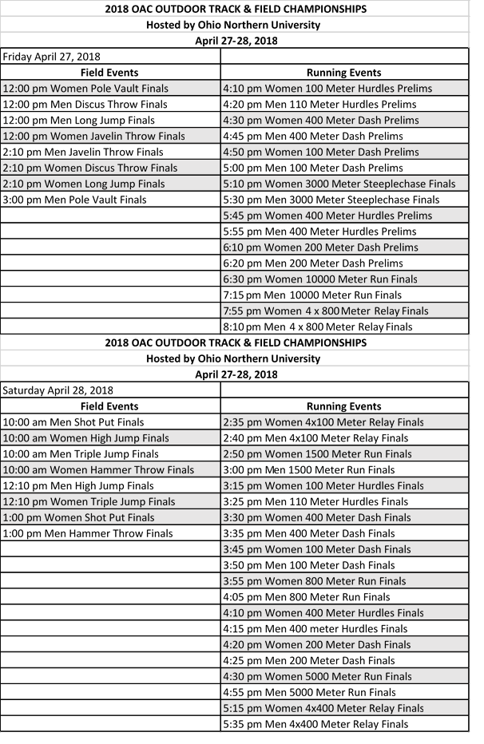
2018 OAC OUTDOOR TRACK & FIELD CHAMPIONSHIPS
MEET CONDUCT

NCAA & OAC Rules

Spikes & Blocks:
Spikes longer than ¼ pyramids are not permitted. They will be checked.
You may use the house starting blocks or your schools (spikes must be ¼ pyramid or less); we will have 1 set of Gill Fusion blocks with Moye pedal available as well.

Team seating and food:
Team camps can be set up outside of the track area in the bleachers or on the hill side or other grass areas. Please clean up your area each night. If we have inclement weather the Stadium and large tent areas will be available for use.

Weigh-Ins:
All Throwing implements must be weighed up during the times listed below. Only implements that pass the weigh in inspection will be allowed during competition. Weigh ins will take place at the white barn adjacent to the throws venue.

Friday Weigh-In: 10:30AM – 11:15AM
Saturday Weigh -In: 8:30AM – 9:15AM

Locker Rooms:
Locker rooms are limited

Concessions:
Will be located in the stadium next to the track. Cash Only. There is no ATM on site.

Admissions:

Spectators will be charged for admissions: Adults $8.00 (2 day pass for $12.00). Senior/ Military (62 years) = $6.00 (2 day pass for $8.00), non-OAC students $3.00 (2 day pass for $5.00). OAC Students are free and OAC lifetime passes are also admitted free of charge.

Ohio Northern University Athletic Training
On behalf of the Athletic Training Department at ONU, we would like to welcome you to Ada for the 2018 OAC Outdoor Track and Field Championship. The following information is to help you prepare for your visit.

The meet will take place in Kerscher Stadium. With the exception of the throws, all T&F venues are inside the track complex. Our main Athletic Training Room is located in Dial-Roberson Stadium.
We will have a satellite AT facility located at the track. This location will have treatment tables, ice, and emergency equipment including biohazard disposal. A certified/licensed athletic trainer will be at or near this location throughout the meet. Our AT students will also be helping.

The Athletic Training Room will be open throughout the championships. A certified/licensed athletic trainer will be in the ATR. Ice, heat and hydrotherapy are available. Electro-modalities including E-Stim and US are available for use by visiting athletic trainers. If you are not traveling with your team, and have an athlete in need of stim or US, please call in advance and arrange for care. A written prescription will be required. Water and cups will be located at several venue locations. Please supply your own water bottles.

We have several hospitals located near Ada. There are 2 in Lima and 1 in Kenton.

Mercy Health St. Rita’s
730 W. Market St.
Lima, OH. 45801
419-227-3361

Lima Memorial Health System
1001 Bellefontaine Ave.
Lima, OH. 45804
419-228-3335

Ohio Health Hardin Memorial Hospital
921 E. Franklin St.
Kenton, OH. 43326
419-673-0761

Feel free to contact our athletic training staff with any questions you might have. Please let Rachael Graham know if you are sending an Athletic Trainer with your team. We look forward to hosting you in Ada, OH.

Ohio Northern University Athletic Training Contacts:
Rachael Graham- AT Kurt Wilson- AT - CSCS
AT assigned to Track and Field Head Athletic Trainer
r-graham.6@onu.edu k-wislon.1@onu.edu
419-772-2447 419-772-2559

